
毕 业 论 文（设 计）外 文 参 考 资 料 及 译 文


译文题目：Optimizing VPN Security in Financial Services:Implementing 256-Bit Encryption and Tunneling Protocols for Secure Data Transmission 金融服务业VPN安全优化：实施256位加密与隧道协议保障 数据传输安全
学生姓名： 学 号：
专 业： 网络工程
所在学院： 网络安全学院
指导教师：
职 称：

年 月 日
说明
要求学生结合毕业论文（设计）课题参阅一篇以上的外文资料（开题报告涉及参考文献中的一篇），并翻译至少一万印刷符（或译出3千汉字）以上的译文。
译文原则上要求打印（如手写，一律用400字方格稿纸书写），连同学校提供的统一封面及英文原文装订，于毕业论文（设计）工作开始后2周内完成，作为成绩考核的一部分。

Optimizing VPN Security in Financial Services:
Implementing 256-Bit Encryption and Tunneling
Protocols for Secure Data Transmission
2025 19th International Conference on Ubiquitous Information Management and Communication (IMCOM) ©2025 IEEE DOI: 10.1109/IMCOM64595.2025.10857544|979-8-3315-0781-7/25/$31.00|

Irma Syarlina Che Ilias
Malaysian Institute of Information Technology
Universiti Kuala Lumpur
Kuala Lumpur, Malaysia
irmasyarlina@unikl.edu.my
Muhammad Zaqwan Ezzad Zulkifli
Malaysian Institute of Information Technology
Universiti Kuala Lumpur
Kuala Lumpur, Malaysia
zaqwan.zulkifli@s.unikl.edu.my

Sera Syarmila Sameon
College of Computing and Informatics
Universiti Tenaga Nasional
Selangor, Malaysia
sera@uniten.edu.my
Mohammad Zahir Mat Salleh
CyberSecurity
RawSec
Kuala Lumpur, Malaysia
zahir@rawsec.my

Abstract—This study examines the essential importance of security in contemporary network settings, emphasizing the increasing dependence on Virtual Private Networks (VPNs) for safe data transfer. The emphasis is on assessing the security attributes of VPNs to enhance existing network systems. This study specifically contrasts the performance and efficacy of two tunneling protocols—Layer 2 Tunneling Protocol version 3 with IPsec (L2TPv3/IPsec) and Generic Routing Encapsulation (GRE) utilizing IPsec—in a site-to-site connection. The study offers an economical solution by leveraging current infrastructure, minimizing the requirement for extra gear like antennas and rented space. Moreover, the study follows the National Institute of Standards and Technology (NIST) security protocols, specifically designed for the financial services sector, guaranteeing a secure and cost-effective approach for data transfer. Initial findings indicate that the best arrangement of VPN tunnels improves security in financial services networks, providing an effective method for protecting direct connections.
Keywords—VPN Security, Tunneling Protocol, 256-Bit Encryption

I. INTRODUCTION
A. Background on the Importance of Network Security in Financial Services
The financial services sector (FSS) is essential to the global economy, consisting of diverse entities including banks, insurance firms, and investment companies. With financial transactions increasingly occurring online, the industry encounters greater risks of cyberattacks. Network security is crucial in this area because of the sensitive information it manages, such as personal data, financial records, and transaction information. A security incident can result in serious repercussions, such as financial losses, harm to reputation, and potential legal issues. It is reported that 78% of firms in the financial services sector have faced a security breach [1]. Additionally, the World Economic Forum has recognized cyberattacks as a significant global threat, highlighting the necessity of strong security protocols in financial systems [2].
The increasing prevalence of complex cyber threats like ransomware, phishing, and advanced persistent threats (APTs) highlights the necessity for improved network security within

the financial services industry. It is essential to employ secure communication protocols and encryption methods to protect network infrastructures from the weaknesses that these threats take advantage of. The PwC Global Economic Crime and Fraud Survey indicated that 46% of financial organizations encountered fraud or economic crime within the previous two years, with cybercrime emerging as the most common type of crime [3]. With risks becoming increasingly intricate, the financial services industry needs to implement a proactive strategy for network security to safeguard assets and uphold client confidence.

B. The Growing Reliance on VPNs for Secure Data Transmission
Virtual Private Networks (VPNs) have emerged as an essential technology for guaranteeing secure data transfer across different locations. With the growth of digital operations in financial institutions and the rise of remote work, there is a heightened need for secure and dependable communication channels. VPNs create protected routes across public networks, enabling secure communication among various branches, staff, and customers. This is especially crucial in the financial services sector, where the integrity and confidentiality of data are essential. A recent study shows that the worldwide VPN industry is projected to expand from USD 50.9 billion in 2023 to USD 137.7 billion by 2030, representing a compound annual growth rate (CAGR) of 15.3%, highlighting the increasing significance of VPNs for both companies and individuals [4].
The utilization of VPNs in the financial industry not only guarantees data security but also aids in adhering to regulatory standards. Regulations like the General Data Protection Regulation (GDPR) and the Payment Card Industry Data Security Standard (PCI DSS) require the implementation of encryption and secure communication methods when processing sensitive financial data. VPNs are vital for protecting the privacy and confidentiality of financial transactions and records, which is important for adhering to regulatory requirements like the Sarbanes-Oxley Act (SOX) and the Gramm-Leach-Bliley Act (GLBA) in the United States, as noted in a LinkedIn piece by Lazarus Alliance [5], Moreover, it was observed that the growth of cloud services and the transition to remote and hybrid work settings have

979-8-3315-0782-4/25/$31.00 ©2025 IEEE
Authorized licensed use limited to: ysr y. Downloaded on June 08,2025 at 03:54:31 UTC from IEEE Xplore. Restrictions apply.

resulted in a heightened dependence on security solutions such as VPNs, which have become crucial for maintaining secure operations in the financial services industry [6].
These trends highlight the increasing dependence on VPNs for secure data transfer in the financial sector, which aligns with the aims of this study to investigate tunnelling protocols and improve network security.

II. LITERATURE REVIEW
The financial services sector (FSS) is crucial to the worldwide economy by enabling capital movement and supporting economic stability. Nonetheless, as financial institutions progressively depend on interconnected networks for providing services, safeguarding the security of sensitive data transmissions has emerged as a vital issue. Virtual Private Networks (VPNs) provide a reliable method by establishing secure communication pathways across public networks. This literature review examines VPN technologies, emphasizing tunneling protocols like Layer 2 Tunneling Protocol with IPsec (L2TP/IPsec) and Generic Routing Encapsulation with IPsec (GRE/IPsec). It also explores the significance of encryption protocols, particularly Advanced Encryption Standard (AES-256), in safeguarding financial networks.

A. VPN Technologies in Financial Networks
Virtual Private Networks (VPNs) are essential for financial organizations to protect data exchanges across widely spread locations. Reference [7] noted that, VPNs improve security through the use of multiple encryption protocols to protect both the confidentiality and integrity of information, thus lowering the chances of data breaches. Additionally, the significance of VPNs in financial networks, including their capability to establish secure, encrypted pathways across public networks is emphasized in [8]. These tunnels employ strong protocols like IPsec, SSL/TLS, and MPLS to guarantee the confidentiality and protection of sensitive data, while also offering extra authentication and access control features, as noted in the same study [8]. The execution of these protocols is essential for safeguarding financial transactions by blocking unauthorized entry and reducing cyber risks, thus ensuring security and confidence.
Earlier studies have examined different VPN setups to identify the best compromise between security and performance. A thorough security assessment of VPNs was performed, highlighting the significance of various VPN technologies and their capacity to balance security with performance, as discussed by [9]. Their analysis shows that while VPNs such as GRE + IPsec and IPIP have unique benefits, GRE + IPsec tunnels typically deliver better Quality of Service (QoS) [9]. Their conclusion on the enhanced performance of GRE + IPsec tunnels regarding packet delivery and latency matches the findings of a study from the previous year by [10]. This study also showed that GRE + IPsec tunnels enhance VoIP performance by providing superior QoS in comparison to IPIP-based solutions. This detailed examination highlights the significance of choosing the right VPN setup to enhance both security and performance for particular applications [10].

B. Tunnelling Protocols: L2TP/IPsec vs. GRE/IPsec
Tunnelling protocols are crucial for creating secure VPN links. Layer 2 Tunnelling Protocol (L2TP), frequently used alongside IPsec for improved security, functions at the data link layer and is notably efficient for establishing virtual LANs over various locations. This combination guarantees robust encryption, making it perfect for settings that necessitate safe and effective communication. In comparison, the Generic Routing Encapsulation (GRE) protocol supports multiple network protocols but does not include inherent security capabilities. Consequently, GRE is frequently combined with IPsec to guarantee secure communication through data encryption. The effectiveness of VPN tunnel protocols greatly influences their capacity to fulfil application service needs, as discovered in [11]. They observed that GRE/IPsec setups provide improved speed and flexibility, yet may lead to increased latency when compared to L2TP/IPsec in consistent, low-latency situations, where performance is emphasized [11]. Furthermore, it was noted that although GRE/IPsec is a dependable method for safeguarding communication across public networks, it might result in slower processing speeds [12].
The role of GRE in improving the security of IPsec VPN tunnelling within IPv6 networks was explored, showing its capability to protect connections in both IPv4 and IPv6 settings [13]. This study offers important perspectives for financial organizations adjusting to changing network infrastructures, highlighting the essential function of GRE/IPsec in maintaining secure and smooth communication between various network protocols [13]. In support of this perspective, the successful implementation of VPNs utilizing L2TP and IPsec protocols, especially for creating links between various locations was emphasized [14]. Their study highlights the significance of choosing the right tunnelling protocols to guarantee strong security and dependability in VPN setups, which is essential for companies functioning in intricate network settings [14].

C. Encryption Protocols: AES-256 and NIST Standards
Encryption is essential for maintaining the security of VPNs. The National Institute of Standards and Technology (NIST) offers recommendations for secure communication, advising the implementation of SSL VPNs for encryption purposes. AES-256, recognized for its robust defence against cyber threats, is commonly used and endorsed in NIST’s SSL VPN Guide, emphasizing the importance of following best practices for secure VPN setups [15]. The necessity of judiciously choosing encryption protocols for financial technology (fintech) applications, supporting the use of layered encryption methods to secure data during both storage and transmission, thereby guaranteeing thorough security within financial networks [16].
Recent studies have increasingly emphasized the vital importance of AES-256 encryption in larger cybersecurity structures. The importance of adopting AES-256 according to NIST guidelines to tackle the unique issues of protecting user data in mobile fintech apps, showing its efficacy in minimizing the likelihood of data breaches [17]. Furthermore, the possible effects of new technologies, including quantum computing, on current encryption methods are investigated [18]. Their study highlights the significance of employing AES-256 and adhering to NIST’s recommendations to uphold

strong security measures, especially amidst emerging technological threats in the financial industry. These results emphasize the necessity for ongoing revisions to encryption protocols to safeguard important data from advancing security risks.

D. Challenges and Future Directions
Although VPNs offer significant security advantages, they encounter issues like latency, throughput, and the ability to adapt to new technologies such as 5G and IoT. The difficulties of merging blockchain technology with 5G networks, highlighting the necessity to address these issues to improve security and operational effectiveness [19]. Furthermore, in the finance industry, it is crucial to focus on the choice of tunnelling protocols and encryption standards, especially the implementation of 256-bit encryption, to guarantee strong VPN security. An innovative idea for edge networking services designed to enhance network efficiency and reduce latency as in [20].
The importance of integrating advanced encryption methods and optimization approaches in financial organizations to boost VPN security, strengthen data safeguarding, and enhance system efficiency is discussed in [21]. Their analysis of the e-IPGP chain system shows that improving data transfer protocols and implementing robust encryption techniques can greatly bolster security. This study offers valuable information on enhancing VPN setups to tackle issues concerning latency and throughput. Furthermore, A comprehensive assessment of the security of IoT IP overlay networks, emphasizing performance and the effects of employing open-source infrastructure, is provided. The study highlights the necessity of improving VPN security for financial networks by incorporating strong encryption and current tunnelling protocols, ensuring that VPN services adapt to changing needs and reduce emerging risks [22].
Consequently, the essential function of VPN technologies in protecting financial networks is highlighted by the implementation of sophisticated encryption and tunnelling protocols. VPNs utilizing L2TP/IPsec and GRE/IPsec protocols are essential for safeguarding information sent through public networks. The significance of robust encryption and tunnelling for maintaining data privacy and integrity is emphasized in studies [7], [8]. The study shows that GRE/IPsec usually provides superior efficiency and lower latency than L2TP/Ipsec [9], [12]. The implementation of AES-256 encryption is vital for protecting financial information, as proposed by [16], [17]. Focusing on VPN security is crucial to tackle issues like latency and throughput, while also guaranteeing compatibility with new technologies such as 5G and IoT. Recent studies provide important
suggestions for optimizing VPN setups to address changing security requirements and boost overall performance [21], [22].
III. METHODOLOGY
The methodology section outlines a systematic approach for evaluating secure network configurations within the financial services industry. Employing a simulation-based research design, as detailed in Table 1, the study conducts a comprehensive comparison of L2TPv3 with IPsec and GRE over IPsec VPN configurations [23]. The analysis focuses on

key factors such as performance, security, and cost- effectiveness, ensuring that the results are relevant and applicable to real-world financial environments.
TABLE I. SIMULATION BASED RESEARCH DESIGN

Stages | Description
Problem  Identification &  Theory  Exploration | Identify network security problems and review relevant system theories.
Conceptual Model  Development | Develop a conceptual model outlining key parameters for VPN configuration evaluation.
Simulation Setup | Configure two VPN setups in GNS3 with consistent routers and protocols.
Data  Transmission &  Monitoring | Transmit data securely via AES-256 encryption, monitored with Wireshark for traffic analysis.
Data Analysis | Analyze latency, packet loss, and encryption efficiency to compare VPN performance.
Findings and  Practical  Implications | Provide actionable insights for optimizing network security in financial institutions.

The study starts by recognizing the issue and examining pertinent system theories related to network security. This fundamental study results in the creation of a conceptual framework that encompasses the essential elements and relationships within the network. The model acts as a structure for the simulation, highlighting the essential parameters and variables that need to be adjusted and examined. This method enables a methodical assessment of how each VPN setup affects security and performance.
In the practical part of the study, two network setups are created using the GNS3 simulation tool. The network design consists of three routers linked via a VPN tunnel, using uniform routing protocols and device types in each configuration. Throughout the simulation, information is sent securely via the VPN tunnel, encrypted with AES-256, and observed with Wireshark. This facilitates the collection of network traffic data, crucial for assessing the systems' performance and security.
Data analysis emphasizes crucial metrics like latency, packet loss, and the efficiency of encryption. The evaluation offers perspectives on the compromises between security and performance across various VPN setups, aiding in determining the optimal configuration for financial services. By assessing these key metrics, the research provides a straightforward comparison that can help in choosing the best VPN option.
This approach offers a comprehensive structure for evaluating VPN setups within a controlled setting, leading to insights that are meaningful and practical. The structured procedure, ranging from identifying issues to analyzing data, guarantees that the research outcomes are solid and pertinent. These findings can help financial organizations enhance network security and effectiveness while tackling the main aspects highlighted in the research.
IV. RESULT AND DISCUSSION
The next section showcases the findings of this study, emphasizing the performance and security characteristics of the two VPN tunnelling protocols being examined: L2TPv3 with IPsec and GRE over IPsec. Both protocols are assessed in a simulated environment to offer a comprehensive comparison of their efficiency in safeguarding data

transmission within financial services networks. This examination focuses on the essential demand for strong encryption while also taking into account the compromises between network efficiency and reliability. This research seeks to offer important insights for network administrators by analysing essential metrics like encryption integrity, throughput, retransmission rates, and latency to help in choosing the best VPN protocol for their operational needs. The results outlined here emphasize the real-world impact of implementing these tunnelling protocols, especially in the financial services industry, where both security and operational effectiveness are crucial.

A. Encryption verification.
1) L2TPv3 with IPsec.
The traffic packet capture using Wireshark for the L2TPv3 with IPsec tunnel, as shown in Fig. 1, reveals that each packet is encrypted using Encapsulating Security Payload (ESP), a component of IPsec. The encrypted traffic conceals detailed source and destination information, displaying only the tunnel address, thereby ensuring robust encryption and maintaining confidentiality.
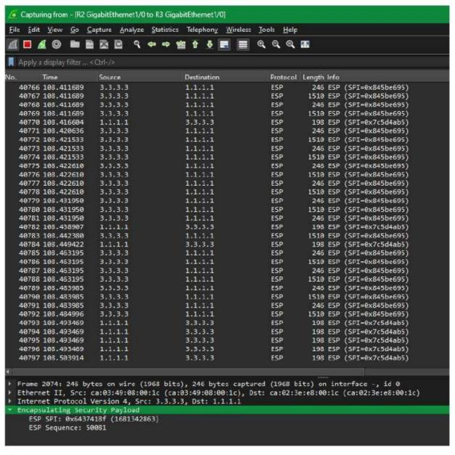

Fig. 1. Packet capture L2TPv3

2) GRE over IPSec
Similarly, the traffic packet capture for the GRE over IPsec tunnel, as shown in Fig. 2, demonstrates that each packet is encrypted using ESP, which obscures the detailed source and destination addresses, displaying only the tunnel address. This indicates that GRE over IPsec also provides a high level of encryption.

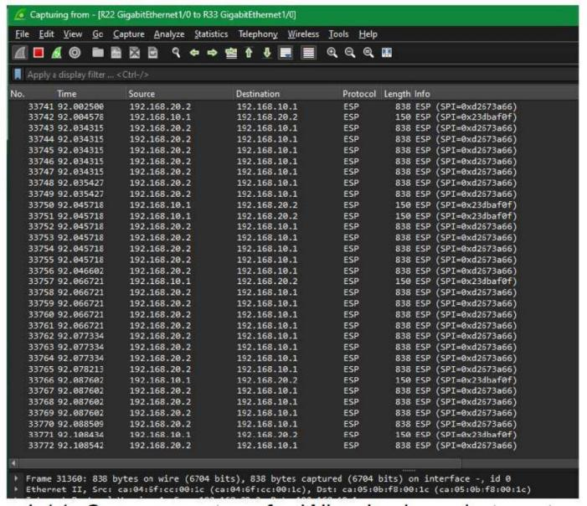

Fig. 2. Packet capture GRE

B. iPerf3 Test.
1) L2TPv3 with IPsec.
Fig. 3 presents the iPerf3 test results for the L2TPv3 with IPsec configuration, showing an average throughput of 1.59 Mbits/sec, 1.58 Mbits/sec, and 2.01 Mbits/sec across three trials. The total data transferred in each trial was 22.8 Mbytes, 22.6 Mbytes, and 28.8 Mbytes, with retransmission counts of
121, 134, and 185, respectively. These results indicate moderate throughput and retransmission rates.

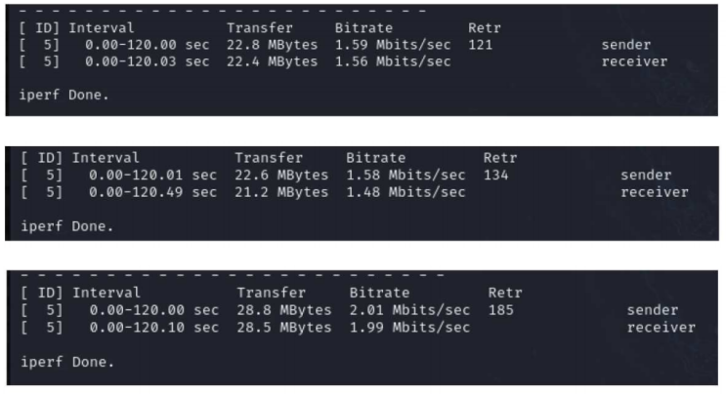

Fig. 3. iPerf3 Test L2TPv3

2) GRE over IPSec
For the GRE over IPsec configuration, Fig. 4 shows that the iPerf3 tests yielded average throughput values of 2.07 Mbits/sec, 2.12 Mbits/sec, and 2.08 Mbits/sec. The total data transferred was 29.6 Mbytes, 30.4 Mbytes, and 29.8 Mbytes, with retransmission counts of 363, 281, and 303, respectively. The higher throughput suggests that GRE over IPsec can accommodate greater data transfer, though this is accompanied by an increase in retransmissions.

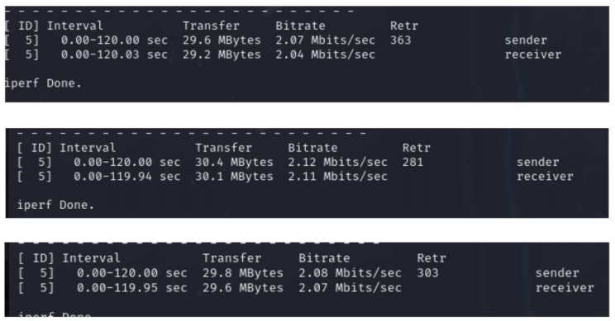

Fig. 4. iPerf3 Test GRE

C. Latency test
1) L2TPv3 with IPsec.
The latency test in Fig. 5 indicates that L2TPv3 with IPsec delivers stable performance, with no packet loss and moderate latency. This makes it a viable option for financial services networks, where secure and reliable point-to-point connections are essential.
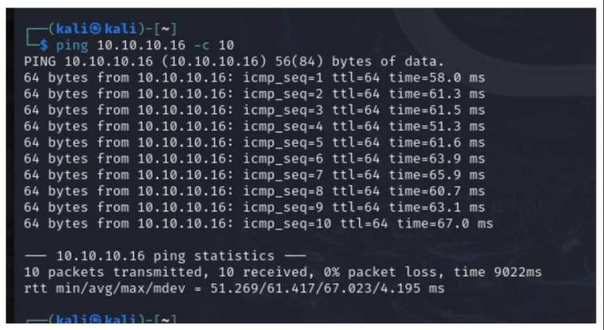

Fig. 5. Ping test L2TPv3

2) GRE over IPSec
The latency test for GRE over IPsec in Fig.6 demonstrates reliable performance with no packet loss, though with more variability in delay. This configuration is more suitable for environments that prioritize higher data transfer rates, even if it results in less consistent latency.
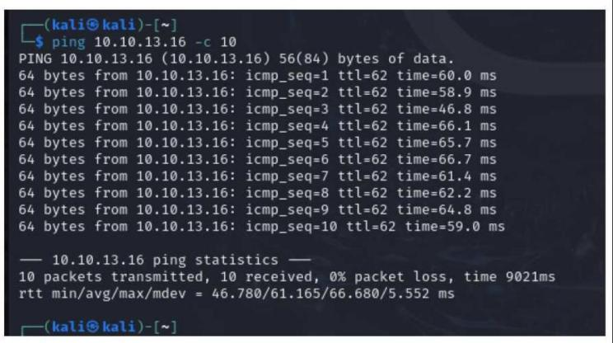

Fig. 6. Ping test GRE

L2TPv3 utilizing IPsec and GRE over IPsec provide robust encryption and reliable functionality, but both present distinct compromises. L2TPv3 combined with IPsec offers consistent latency and robust throughput, making it suitable for environments that prioritize secure and reliable connections, such as financial services. On the other hand, GRE over IPsec offers higher throughput but results in increased retransmissions and variable latency. This might be beneficial in scenarios where rapid data transfer is prioritized over consistent latency. In the end, the decision about these protocols should rely on the specific security and performance requirements of the network.
One constraint of this study is its reliance on a simulated setting, which may not fully capture the complexities of real- world financial systems. Aspects such as variations in network equipment, traffic patterns, and geographical distribution were ignored; nevertheless, these factors might impact the effectiveness and security of VPN protocols. Furthermore, the study did not explore novel encryption methods or advanced network configurations, which could provide alternative options. Further investigation is necessary to examine these factors in practical environments and evaluate the enduring efficacy and scalability of the VPN configurations across different operational scenarios.

V. CONCLUSION AND RECOMMENDATION
This research assessed the effectiveness of L2TPv3/IPsec and GRE/IPsec tunnelling protocols within a simulated financial services network setting. The results suggest that GRE/IPsec provides superior throughput and data transfer speeds, rendering it ideal for applications where performance is crucial. Conversely, L2TPv3/IPsec shows improved stability with reduced retransmissions, likely offering benefits in situations where network reliability is crucial. Both protocols showed comparable latency, indicating that either one could be utilized for secure data transfer in financial services. These findings offer important guidance for financial institutions in choosing the ideal VPN solution tailored to their unique security and performance requirements. The research emphasizes the significance of finding a balance between cost-effectiveness and regulatory compliance, especially in following National Institute of Standards and Technology (NIST) guidelines, to guarantee strong and secure network operations.
While the simulated setting offered valuable insights, additional research is needed to enhance these results. Future research should involve assessing these VPN setups in practical environments to consider physical elements, like room temperature and cable length, that may influence performance. Moreover, utilizing advanced network monitoring tools like SolarWinds, along with performance testing software such as SmokePing, may yield more thorough performance information. Exploring more intricate network configurations, like various routing paths and VLAN setups, would further improve comprehension of how these protocols operate in different circumstances. Tackling these aspects will enable organizations to enhance their network security strategies, guaranteeing safe and effective data transmission within financial services networks.

ACKNOWLEDGMENT
We would like to express our sincere gratitude to UniKL MIIT for its invaluable support and resources throughout this study. The institution's dedication to advancing technological study and promoting academic excellence has played a pivotal role in the development of this study. We also extend our appreciation to all individuals and departments who contributed their expertise and time, ensuring the successful completion of this project.

REFERENCES

[1] Parachute Cloud, "Cyber Attack Statistics, Data, and Trends," Parachute Cloud. [Online]. Available: https://parachute.cloud/cyber-attack- statistics-data-and-trends/. [Accessed: Sep. 3, 2024].
[2] World Economic Forum, "The U.S. Tools for Breaking Encryption and Quantum Computing: NIST's New Approach," Aug. 2024. [Online].
Available: https://www.weforum.org/agenda/2024/08/us-tools-
encryption-breaking-quantum-computing-nist/. [Accessed: Sep. 3, 2024].
[3] PwC, "Global Economic Crime and Fraud Survey 2022,"
PricewaterhouseCoopers, 2022. [Online]. Available: https://www.pwc.com/gx/en/services/forensics/economic-crime-
survey/2022.html. [Accessed: Aug. 29, 2024].
[4] BusinessWire, "Virtual Private Network (VPN) Business Analysis Report 2024: Global Market to Reach $137.7 Billion by 2030 from $50 Billion in 2023," Aug. 22, 2024. [Online]. Available: https://www.businesswire.com/news/home/20240822995794/en/Virtua l-Private-Network-VPN-Business-Analysis-Report-2024-Global-
Market-to-Reach-137.7-Billion-by-2030-from-50-Billion-in-2023--- VPNs-Continue-to-Gain-Prominence-for-Businesses-Consumers-
Alike---ResearchAndMarkets.com. [Accessed: Sep. 3, 2024].
[5] Lazarus Alliance, "VPNS & Cybersecurity," LinkedIn, Aug. 1, 2024.
[Online]. Available: https://www.linkedin.com/pulse/vpns- cybersecurity-lazarus-alliance-lbldc/. [Accessed: Sep. 3, 2024].
[6] Gartner, Inc., "Gartner Identifies Three Factors Influencing Growth in Security Spending," Oct. 13, 2022. [Online]. Available: https://www.gartner.com/en/newsroom/press-releases/2022-10-13-
gartner-identifies-three-factors-influencing-growth-i. [Accessed: Sep. 3, 2024].
[7] M. O. Akinsanya, C. C. Ekechi, and C. D. Okeke, "Virtual Private Networks (VPN): A Conceptual Review of Security Protocols and Their Application in Modern Networks," Engineering Science & Technology Journal, vol. 5, no. 4, pp. 1452-1472, 2024, doi: 10.51594/estj.v5i4.1076.
[8] K. K. Jyothi and B. I. Reddy, "Study on Virtual Private Network (VPN), VPN’s Protocols and Security," Int. J. Sci. Res. Comput. Sci. Eng. Inf. Technol., vol. 3, no. 5, pp. 919-926, 2018.
[9] H. Abbas, N. Emmanuel, M. F. Amjad, T. Yaqoob, M. Atiquzzaman, Z.
Iqbal, and U. Ashfaq, "Security assessment and evaluation of VPNs: a

comprehensive survey," ACM Comput. Surv., vol. 55, no. 13s, pp. 1-
47, 2023.
[10] S. Budiyanto and L. M. Silalahi, "Analysis QoS VoIP using GRE + IPSec Tunnel and IPIP Based on Session Initiation Protocol," in Proc. 2022 5th Int. Conf. Comput. Informatics Eng. (IC2IE), Jakarta, Indonesia, 2022, pp. 47-54, doi: 10.1109/IC2IE56416.2022.9970120.
[11] H. Akter, S. Jahan, S. Saha, R. H. Faisal, and S. Islam, "Evaluating Performances of VPN Tunneling Protocols Based on Application Service Requirements," in Proc. 3rd Int. Conf. Trends Comput. Cogn. Eng., M. S. Kaiser, K. Ray, A. Bandyopadhyay, K. Jacob, and K. S. Long, Eds. Singapore: Springer, 2022, pp. 345-357. doi: 10.1007/978- 981-16-7597-3_36.
[12] K. A. Ogudo, "Analyzing Generic Routing Encapsulation (GRE) and IP Security (IPSec) Tunneling Protocols for Secured Communication over Public Networks," in Proc. 2019 Int. Conf. Adv. Big Data Comput. Data Commun. Syst. (icABCD), Winterton, South Africa, 2019, pp. 1-9, doi: 10.1109/ICABCD.2019.8851004.
[13] M. R. Uddin, N. A. Evan, M. R. Alam, and M. T. Arefin, "Analysis of Generic Routing Encapsulation (GRE) over IP Security (IPSec) VPN Tunneling in IPv6 Network," in Ubiquitous Commun. Netw. Comput., N. Kumar, M. Vinodhini, and R. R. Venkatesha Prasad, Eds. Cham: Springer, 2021, pp. 1-11. doi: 10.1007/978-3-030-79276-3_ 1.
[14] B. Santoso, A. Sani, T. Husain, and N. Hendri, "VPN Site to Site Implementation Using Protocol L2TP and IPsec," TEKNOKOM, vol. 4, no. 1, pp. 30–36, 2021, doi: 10.31943/teknokom.v4i1.59.
[15] NIST, "Guide to SSL VPNs," NIST Special Publication 800-113, National Institute of Standards and Technology, Gaithersburg, MD, USA, Jul. 2008. DOI: 10.6028/NIST.SP.800-113.
[16] O. P. Olaiya, T. O. Adesoga, A. A. Adebayo, F. M. Sotomi, O. A.
Adigun, and P. M. Ezeliora, "Encryption techniques for financial data security in fintech applications," Int. J. Sci. Res. Arch., vol. 12, no. 1, pp. 2942-2949, 2024.
[17] A. Y. Balogun, K. N. Peprah, S. O. Martins, S. Obielu, J. O. Adegede, I. A. Odoguje, and E. Mmadueke, "Cybersecurity in mobile fintech applications: Addressing the unique challenges of securing user data," 2024.
[18] J. Deodoro, M. Gorbanyov, M. Malaika, and T. S. Sedik, "Quantum computing and the financial system: spooky action at a distance?," Int. Monetary Fund, 2021.
[19] S. Onopa and Z. Kotulski, "State-of-the-art and new challenges in 5G networks with blockchain technology," Electronics, vol. 13, no. 5, pp. 974, 2024.
[20] L. Brown, E. Marx, D. Bali, E. Amaro, D. Sur, E. Kissel, ... and S.
Shenker, "An architecture for edge networking services," in Proc. ACM SIGCOMM 2024 Conf., Aug. 2024, pp. 645-660.
[21] R. Rafik, A. Ettaoufik, and A. Maizate, "Securing Medical Data Exchange: A Decentralized Approach Based on the e-IPGPChain Framework," Int. J. Saf. Secur. Eng., vol. 14, no. 3, 2024.
[22] A. F. Gentile, D. Macrì, E. Greco, and P. Fazio, "IoT IP Overlay Network Security Performance Analysis with Open Source Infrastructure Deployment," J. Cybersecurity Priv., vol. 4, no. 3, pp. 629-649, 2024.
[23] J. Beese, M. K. Haki, S. Aier, and R. Winter, "Simulation-based research in information systems: epistemic implications and a review of the status quo," Bus. Inf. Syst. Eng., vol. 61, pp. 503-521, 2019.
金融服务业VPN安全优化：实施256位加密与隧道协议保障数据传输安全
Irma Syarlina Che Ilias¹⁾ Sera Syarmila Sameon²⁾
Muhammad Zaqwan Ezzad Zulkifli³⁾ Mohammad Zahir Mat Salleh⁴⁾
1)(吉隆坡大学 马来西亚信息技术研究院, 吉隆坡 马来西亚 irmasyarlina@unikl.edu.my)
2)(国能大学 计算与信息科学学院, 雪兰莪州 马来西亚 sera@uniten.edu.my)
3)(吉隆坡大学 马来西亚信息技术研究院, 吉隆坡 马来西亚 zaqwan.zulkifli@s.unikl.edu.my)
4)(RawSec 网络安全, 吉隆坡 马来西亚 zahir@rawsec.my)

摘 要：本文探讨了网络安全在当代网络环境中的核心重要性，文章强调虚拟专用网络（VPN）在安全数据传输方面日益增长的依赖性，研究重点在于评估VPN的安全特性以增强现有网络系统。本研究特别对比了两种隧道协议在站点到站点连接中的性能与效能：采用IPsec的第二层隧道协议第3版（L2TPv3/IPsec）与利用IPsec的通用路由封装协议（GRE），研究通过利用现有基础设施，减少对天线、租赁场地等额外设备的需求，提供了经济高效的解决方案。此外，研究遵循美国国家标准与技术研究院（NIST）专门为金融服务业设计的安全协议，确保数据传输既安全又具成本效益。研究结果表明，优化的VPN隧道配置能提升金融服务网络的安全性，为保护直连通信提供了有效方法。
关键词：VPN安全，隧道协议，256位加密
DOI:10.1109/IMCOM64595.2025.10857544

1 引言

1.1 金融服务领域网络安全的重要性背景
金融服务行业（FSS）作为全球经济支柱，涵盖银行、保险公司、投资机构等多元实体，随着金融交易日益线上化，该行业面临更大的网络攻击风险。网络安全在此领域至关重要，因其涉及个人数据、财务记录、交易信息等敏感内容。安全事件可能导致严重后果，包括经济损失、声誉损害及法律纠纷。据报道，78%的金融服务企业遭遇过安全漏洞^{[1]}，世界经济论坛更将网络攻击列为全球重大威胁，强调金融系统必须建立强效安全协议^{[2]}。
勒索软件、钓鱼攻击、高级持续性威胁（APT）等复杂网络威胁的激增，凸显了金融服务业强化网络安全的紧迫性，采用安全通信协议与加密技术对保护网络基础设施免受漏洞利用至关重要。普华永道全球经济犯罪调查显示，46%的金融机构近两年遭遇过欺诈或经济犯罪，其中网络犯罪占比最高^{[3]}。随着风险形态日趋复杂，金融服务业需采取主动式网络安全策略，以保障资产安全并维护客户信任。

1.2 VPN在安全数据传输中的依赖性增长
虚拟专用网络（VPN）已成为保障跨地域数据传输安全的关键技术，随着金融机构数字化转型与远程办公兴起，对安全可靠通信管道的需求激增，VPN通过在公共网络建立加密通道，实现分支机构、员工与客户间的安全通信，这对数据完整性与保密性要求严苛的金融服务业尤为重要。最新研究显示，全球VPN市场规模预计将从2023年的509亿美元增长至2030年的1377亿美元，年复合增长率（CAGR）达15.3%，印证了VPN对企业与个人日益提升的重要性^{[4]}。
金融业使用VPN不仅保障数据安全，更有助于合规。欧盟《通用数据保护条例》（GDPR）和《支付卡行业数据安全标准》（PCI DSS）等法规要求处理敏感财务数据时须采用加密与安全通信手段。如Lazarus Alliance在领英文章中指出，VPN对保护金融交易与记录的隐私性至关重要，这符合美国《萨班斯-奥克斯利法案》（SOX）和《格雷姆-里奇-布莱利法案》（GLBA）等合规要求^{[5]}。此外，云服务普及与远程/混合办公模式的转型，使得VPN等安全解决方案成为维持金融服务业安全运营的核心要素^{[6]}。
这些趋势表明金融领域对VPN安全传输的依赖性持续增强，与本研究探索隧道协议、提升网络安全的目标高度契合。

2 文献综述
金融服务行业（FSS）通过促进资本流动和维护经济稳定，对全球经济至关重要。然而，随着金融机构日益依赖互联网络提供服务，保障敏感数据传输安全已成为关键议题。虚拟专用网络（VPN）通过在公共网络上建立安全通信通道，提供了可靠的解决方案。本文献综述研究了VPN技术，重点分析了结合IPsec的第二层隧道协议（L2TP/IPsec）和通用路由封装协议（GRE/IPsec），并探讨了高级加密标准（AES-256）等加密协议在保护金融网络中的重要性。

2.1 金融网络中的VPN技术
虚拟专用网络（VPN）对金融机构保护跨地域数据交换至关重要。文献^{[7]}指出，VPN通过多重加密协议保障信息机密性与完整性，有效降低数据泄露风险。研究^{[8]}进一步强调VPN在金融网络中的核心价值，包括其建立公共网络加密通道的能力。如该研究所述，这些隧道采用IPsec、SSL/TLS和MPLS等强效协议，在确保敏感数据安全的同时，还提供额外身份验证和访问控制功能。这些协议的实施对阻止未授权访问、降低网络风险、维护金融交易安全与信任具有关键作用。
现有研究通过评估不同VPN配置来寻求安全与性能的最佳平衡，文献^{[9]}开展的全面安全评估表明，虽然GRE+IPsec和IPIP等VPN各有优势，但GRE+IPsec隧道通常能提供更优质的服务质量（QoS）。该结论与文献^{[10]}早前关于数据包传输延迟的研究结果一致，后者还证实GRE+IPsec隧道在语音传输（VoIP）性能上优于IPIP方案，这些深入分析凸显了根据具体应用场景选择合适VPN配置对优化安全与性能的重要性。

2.2 隧道协议：L2TP/IPsec与GRE/IPsec对比
隧道协议是建立VPN安全连接的核心技术，第二层隧道协议（L2TP）常与IPsec配合使用，在数据链路层运行，特别适合构建跨地域虚拟局域网。这种组合提供强加密特性，完美契合需要安全高效通信的环境。相比之下，通用路由封装协议（GRE）虽支持多网络协议，但缺乏原生安全机制，因此常需配合IPsec实现数据加密。文献^{[11]}发现，VPN隧道协议的性能直接影响其满足应用服务需求的能力：GRE/IPsec配置在速度与灵活性上占优，但在强调性能的稳定低延迟场景中，其延迟表现可能逊于L2TP/IPsec。研究^{[12]}也指出，GRE/IPsec虽是保护公共网络通信的可靠方案，但可能导致处理速度下降。
针对GRE在IPv6网络增强IPsec VPN隧道安全性的研究^{[13]}，证实了其在双协议环境中的连接保护能力。该研究为金融机构适应网络基础设施演进提供了重要参考，阐明了GRE/IPsec在保障多协议网络间安全无缝通信的关键作用。文献^{[14]}则重点论证了L2TP与IPsec协议在构建跨地域连接方面的成功实践，强调选择恰当的隧道协议对确保VPN配置安全可靠的决定性意义，这对复杂网络环境下的企业运营尤为关键。

2.3 加密协议：AES-256与NIST标准
加密技术是维护VPN安全的基石，美国国家标准与技术研究院（NIST）在其安全通信指南中推荐采用SSL VPN进行加密。被NIST SSL VPN指南列为标准实践的AES-256加密，以其卓越的网络安全防护能力被广泛采用，该指南同时强调了遵循VPN安全配置最佳实践的重要性^{[15]}。针对金融科技应用，研究^{[16]}提出应审慎选择加密协议，建议采用分层加密方法保护存储与传输中的数据，从而确保金融网络的全面安全。
近期研究日益强调AES-256加密（高级加密标准-256位）在大型网络安全架构中的关键作用。采用符合NIST（美国国家标准与技术研究院）指南的AES-256加密方案，能有效解决移动金融科技应用中用户数据保护的独特问题，其降低数据泄露风险的效果已得到验证^{[17]}。研究还探讨了量子计算等新兴技术对现有加密方法的潜在影响^{[18]}。该研究特别指出，在金融行业面临新兴技术威胁的背景下，采用AES-256并遵循NIST建议对维持强安全措施至关重要。这些发现表明，必须持续更新加密协议以防范不断演进的安全风险，保护核心数据安全。

2.4 挑战与未来方向
尽管VPN能提供显著安全优势，但仍面临延迟、吞吐量及适应5G与物联网等新技术的挑战。研究^{[19]}指出区块链技术与5G网络融合的困难，强调必须解决这些问题以提升安全性和运营效能。在金融领域，重点关注隧道协议选择及加密标准（特别是256位加密的实施）对确保VPN强安全性至关重要。文献^{[20]}提出了一种旨在提升网络效率、降低延迟的边缘网络服务创新方案。
文献^{[21]}论述了金融机构整合先进加密方法与优化方案对提升VPN安全性、强化数据保护及提高系统效能的重要性。其对e-IPGP链系统的分析表明，改进数据传输协议并实施强加密技术可大幅增强安全性。该研究为解决延迟和吞吐量问题提供了VPN配置优化的重要见解。此外，研究还对物联网IP覆盖网络的安全性进行了全面评估，重点关注性能表现及采用开源基础设施的影响。研究^{[22]}强调，必须通过整合强加密和现代隧道协议来提升金融网络VPN安全性，确保VPN服务能适应需求变化并降低新兴风险。
由此可见，实施高级加密与隧道协议凸显了VPN技术在保护金融网络中的核心作用。采用L2TP/IPsec和GRE/IPsec协议的VPN对保障公共网络传输信息的安全至关重要。研究^{[7][8]}强调强加密与隧道技术对维护数据隐私和完整性的意义。研究表明GRE/IPsec通常较L2TP/IPsec具有更高效率和更低延迟^{[9][12]}。如文献^{[16][17]}所述，实施AES-256加密对保护金融信息具有决定性作用。聚焦VPN安全对解决延迟和吞吐量问题至关重要，同时需确保与5G及物联网等新技术的兼容性。近期研究为优化VPN配置以适应安全需求变化、提升整体性能提供了重要建议^{[21][22]}。

3 研究方法
本方法章节阐述了金融服务业安全网络配置评估的系统方案。如表1所述，研究采用基于仿真的实验设计，对L2TPv3+IPsec与GRE over IPsec两种VPN配置进行全面对比^{[23]}。分析聚焦性能、安全性和成本效益等关键因素，确保研究结果对真实金融环境具有适用价值。
表1 基于仿真的研究设计
阶段 | 描述
问题识别与理论探索 | 识别网络安全问题并回顾相关系统理论。
概念模型开发 | 开发用于评估VPN配置关键参数的概要性概念模型。
模拟环境搭建 | 在GNS3中配置两套采用相同路由器和协议的VPN方案。
数据传输与监控 | 通过AES-256加密安全传输数据，使用Wireshark进行流量监控分析。
数据分析 | 分析延迟、丢包率和加密效率以对比VPN性能。
研究发现与实践意义 | 为金融机构优化网络安全提供可操作的指导意见。
研究始于对问题的识别及对网络安全相关系统理论的考察。这项基础性研究构建了一个涵盖网络核心要素与相互关系的概念框架。该模型作为仿真基础架构，明确了需要调整和检测的关键参数与变量。这种方法能系统评估每种VPN配置对安全性和性能的影响。
在实践环节，研究使用GNS3仿真工具搭建两种网络配置。网络设计采用三台路由器通过VPN隧道互联，各配置采用统一路由协议和设备类型。仿真过程中，数据通过AES-256加密的VPN隧道安全传输，并借助Wireshark进行监测。这为评估系统性能和安全性的关键网络流量数据采集提供了条件。
数据分析聚焦延迟、丢包率和加密效率等核心指标。评估结果揭示了不同VPN配置下安全性与性能的权衡关系，为确定金融服务最优配置提供依据。通过这些关键指标的对比，研究给出了直观的VPN方案选择参考。
该方法为受控环境下的VPN评估提供了完整框架，所得结论兼具理论价值与实践意义。从问题识别到数据分析的标准化流程，确保了研究结论的可靠性与相关性。这些发现可助力金融机构在应对研究中强调的核心要素时，同步提升网络安全性与运行效能。

4 结果与讨论
本节展示两种受检VPN隧道协议（L2TPv3 with IPsec和GRE over IPsec）的性能与安全特性研究成果，通过在仿真环境中对两种协议的全面效能对比，重点考察金融服务网络数据传输保护中加密强度需求与网络效率、可靠性之间的平衡关系。研究通过分析加密完整性、吞吐量、重传率及延迟等核心指标，为网络管理员选择符合业务需求的最佳VPN协议提供重要参考。研究结果特别强调了这些隧道协议在金融服务业的应用实效，该领域对安全性与运营效能有着双重严苛要求。

4.1 加密验证

4.1.1 L2TPv3和 IPsec
如图1所示，通过Wireshark捕获的L2TPv3 with IPsec隧道流量包显示：每个数据包均采用IPsec组件，封装安全载荷（ESP）进行加密，加密流量隐藏了详尽的源地址与目的地址信息，仅显示隧道地址，从而确保强加密性与机密性。
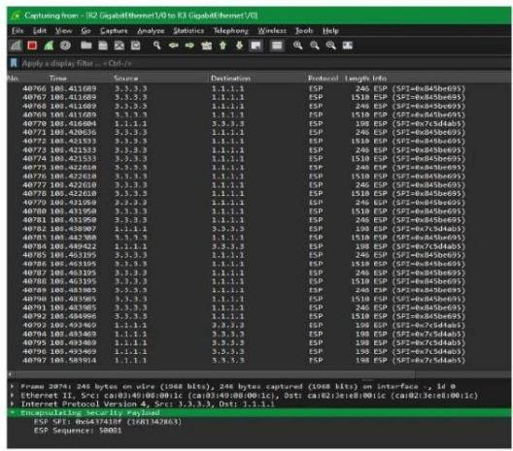
图1 L2TPv3数据包捕获

4.1.2 GRE over IPSec
类似地，图2所示的GRE over IPsec隧道流量包捕获表明：每个数据包同样采用ESP加密，模糊化处理了详细的源地址与目的地址，仅显示隧道地址，这证明GRE over IPsec同样提供高级别的加密保护。
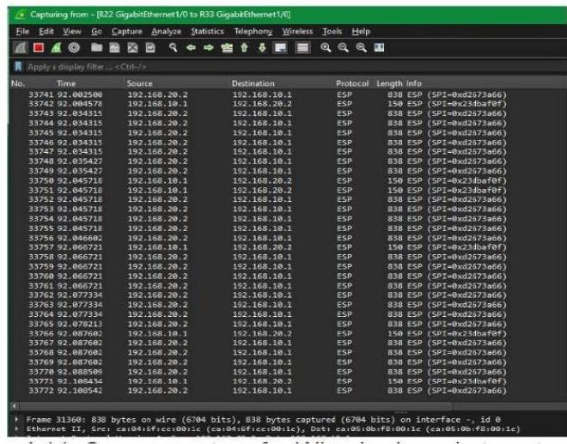
图2 GRE数据包捕获

4.2 iPerf3测试

4.2.1 L2TPv3 with IPsec
图3展示了L2TPv3 with IPsec配置的iPerf3测试结果：三次试验的平均吞吐量分别为1.59 Mbits/秒、1.58 Mbits/秒和2.01 Mbits/秒，传输数据总量对应为22.8 MB、22.6 MB和28.8 MB，重传次数分别为121次、134次和185次，这些结果表明该配置具有中等水平的吞吐量与重传率。
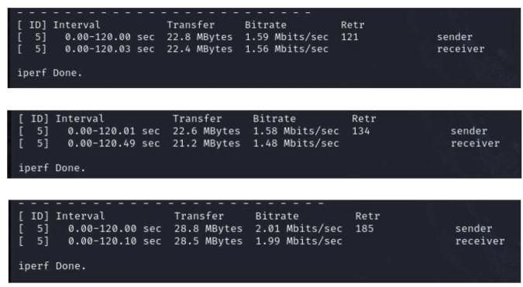
图3 iPerf3测试L2TPv3

4.2.2 IPSec上的GRE隧道
在IPSec上配置GRE隧道时，图4显示iPerf3测试获得的平均吞吐量分别为2.07兆比特/秒、2.12兆比特/秒和2.08兆比特/秒。传输数据总量为 $29.6M$ 字节、30.4兆字节和29.8兆字节，对应的重传次数分别为363次、281次和303次。较高的吞吐量表明IPSec上的GRE隧道能承载更大数据传输量，但这也伴随着重传次数的增加。
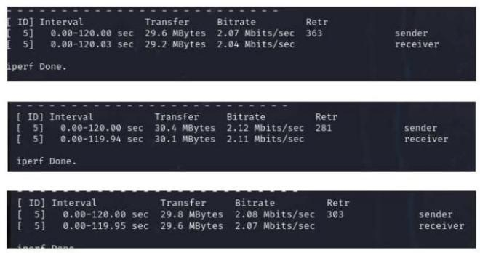
图4 iPerf3测试GRE

4.3 延迟测试

4.3.1 采用IPSec的L2TPv3
图5的延迟测试表明，采用IPSec的L2TPv3能提供稳定性能，无数据包丢失且延迟适中。这使其成为金融服务网络的可行选择，因为该场景需要安全可靠的点对点连接。
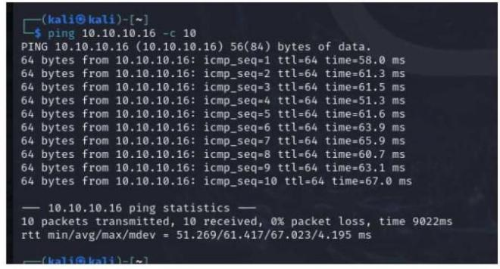
图5 L2TPv3的Ping测试

4.3.2 IPSec上的GRE隧道
图6对IPSec上GRE隧道的延迟测试显示其性能可靠无丢包，但延迟波动较大，该配置更适合优先考虑高数据传输速率的场景，即使会导致延迟稳定性降低。
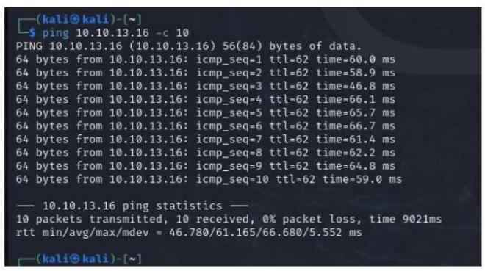
图6 GRE的Ping测试
采用IPSec的L2TPv3与IPSec上的GRE隧道都能提供强加密和可靠功能，但各有折衷。L2TPv3结合IPSec具有稳定的延迟和强劲吞吐量，适合金融服务等重视安全可靠连接的场景；而IPSec上的GRE隧道吞吐量更高，但会导致重传增加和延迟波动，这在重视快速数据传输胜过延迟稳定性的场景可能更具优势。最终协议选择应取决于网络的具体安全与性能需求。
本研究的一个局限是依赖模拟环境，可能无法完全反映真实金融系统的复杂性。网络设备差异、流量模式和地理分布等因素未被纳入考量，而这些可能影响VPN协议的有效性与安全性。此外，研究未探索新型加密方法或高级网络配置方案。后续需在实际环境中检验这些因素，评估不同运营场景下VPN配置的长期效能与扩展性。

5 结论与建议
本研究评估了模拟金融服务网络环境中L2TPv3/IPsec和GRE/IPsec隧道协议的效能。结果表明GRE/IPsec提供更优的吞吐量和数据传输速度，适合性能关键型应用；而L2TPv3/IPsec稳定性更佳且重传更少，在网络可靠性至关重要的场景更具优势。两种协议延迟表现相当，均可用于金融服务的安全数据传输。这些发现为金融机构根据自身安全与性能需求选择最佳VPN方案提供了重要指导。研究强调了在成本效益与合规性（特别是遵循NIST标准）之间取得平衡的重要性，以确保网络运营的稳健安全。
虽然模拟环境提供了有价值的数据，仍需进一步研究完善结论。未来工作应包括在实际环境中评估这些VPN方案，考量室温、线缆长度等可能影响性能的物理因素。此外，结合SolarWinds等高级网络监控工具与SmokePing等性能测试软件，可获取更全面的性能数据。研究更复杂的网络配置（如多路由路径和VLAN设置）将深化对不同场景下协议表现的理解。解决这些方面将帮助机构优化网络安全策略，确保金融服务网络中数据传榆的安全高效。

